AGB Software Submission Requirements

Section 1. The Software Submission Process
All software submissions to Nintendo of America Inc. must be forwarded to the attention of NOA Product Testing Supervisor. Otherwise, the submission’s placement into the testing queue may be delayed. To help reduce a submission’s turn-around time, it is suggested that licensees assign a primary contact person for each software submission. All communications with NOA concerning a submission’s testing status should be forwarded through this individual. The contact person should also be responsible for notifying any other interested parties.
When a submission is approved, your company's primary contact will be notified by NOA Licensing Department in writing.
When a submission is not approved, NOA may send a file in MPEG format illustrating the programming problem(s) which prevent(s) the submission from being approved. This is intended to assist the licensee in analyzing the cause of the software problem. It is the licensee’s responsibility to send a copy of this file to any developer(s) of the software. NOA strongly encourages that copies be sent to the software developer(s) as quickly as possible.
Software submissions should be sent to the following address:
Nintendo of America Inc.
Attn: Engineering, Product Testing Supervisor
4820 150th Avenue NE
Redmond, WA 98052
Phone: (425) 861-2819
Fax: (425) 861-2845

Section 2. Items Required for Submissions
The following items must be submitted with each Game Boy Advance software submission.

2.1 ROM Data
When submitting ROM data, prepare 1 set of CD-R disks, or FTP the file directly to NOA Product Testing (Lotcheck) group.
(Note) With a CD-R disk, make sure it is a format that can be read with Windows95/98.
(Note) For details see, Section 4. Saving Data to a Disk (page 9) .
(Note) To gain access to NOA Lotcheck's FTP, please E-mail Lotcheck@noa.nintendo.com. (Note) A note regarding software that supports AGB communication. If the link communication is only accessible after completing one hour or more of gameplay, provide a back-up data file with your submission to allow quick access to this option.

2.2 AGB Game Pak Specification Sheet
The most recent version is Form 2000-01.
Refer to the following pages when completing this form.

2.3 Instruction Manual
If an official version of the User’s Manual is not completed, please provide a simplified version which contains Controller Functions and Save procedures for the game.

2.4 Software Destination Declaration
Please fill out the Software Destination Declaration/Checklist (SDD) completely and accurately. This form is available at http://www.noa-engineering.com. The document is necessary to ensure the software is distributed to the proper department/person.

2.5 ESRB Rating Certificate
Nintendo must receive a copy of the ESRB rating cerficiate prior to testing any Lot Check submissions. If you have not yet received the certificate from the ESRB, please send us a copy of the video tape you submitted to the ESRB. In this event, please send the certificate upon receipt from the ESRB.
Note: Nintendo will only approve products which are rated by the ESRB and do not receive an Adult Only (AO) rating.
Note: If you have not yet received the certificate from the ESRB, please send us a copy of the video tape you submitted to the ESRB. In this event, please send the certificate upon receipt from the ESRB.

Section 3. Completing the AGB Software Specification Sheet
Please complete the following items on the "AGB Software Specification Sheet".
For your convenience, this sheet is included at the end of this document in an "Online" format, which includes standard Word "Help" functions. If you choose this format, please complete your entries online, print the form, and send it along with your game submission. Please don't forget to print out the SDD/Checklist, fill in your entries, and include it as well.
As an alternative, this document and forms are also included in PDF format. If you choose this format, please print out the forms and fill them out by hand.

3.1 Game Title
Print the name of your game.

3.2 Game Code
Print the Game Code provided to you by Nintendo of America Inc.
(Note) If you have not received a Game Code, you may request this by E-mailing Lotcheck@noa.nintendo.com. Please include the following information:
Game Title
Publisher
"AGB"
ROM Size
Back-up Memory Type/Size
Accessories used (if any)
Any markets where game is planned to be released (Game Code if previously assigned)

3.3 Language
Indicate the primary language used for messages in the game.

3.4 Support for AGB Game Link Cable
(If the communication cable is supported, please attach a document which includes the game specifications and a detailed explanation of the communication functions used.)
Following the example below, check if Multi-Game Pak mode is supported(*1), if Single Game Pak mode is supported(*2), number of players supported, etc.
Example:
This is a car racing game. If two people have the same game two people can play, if three people have the same game three can play, and if four have the same game four can play. If only one person has a Game Pak, up to three people can play a special course(one level) which is not in the normal modes. Additionally, in this Single Game Pak Mode if the software is inserted in the slave, you can load your custom made car and race on this special course against others’ customized cars. (If no software is inserted in the slave, you can only select the default car).”
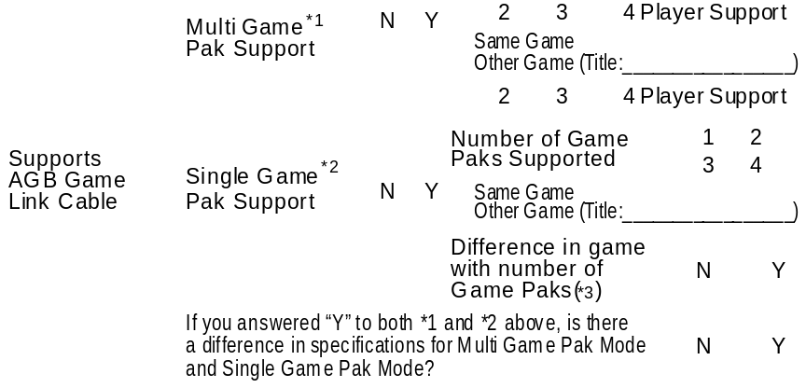
Using the above example the form would be completed as follows:

- Multi-Game Pak Support: This game supports Multi Game Paks so check “Y”.
Players Supported: From 2 to 4 players can play so check 2, 3, and 4.
Supported Games: Only communication between the same game is supported so check "Same Game".
(If the game can be connected with another game title, please check “Other Game” and specify the game title.)
- Single Game Pak Support: This game supports 1 Game Pak so check “Y”.
Players Supported: From 2 to 3 players can play so check 2 and 3.
Number of Game Paks Can Use: Possible to load saved data from a maximum of 3 peoples’ Game Paks, so check 1, 2, and 3.
Supported Games: Only communication between the same game title is supported so check “Same Game”.
(If the game can be connected with another game title, please check “Other Game” and specify the game title.)
-Difference in specifications with different number of Game Paks:
In this game, the difference is that if you have a Game Pak you can load saved data so check “Y”.
-Difference between Multi-Game Pak and Single Game Pak:
In this game, there is a difference in the courses and number of players supported for both game modes so check “Y”.
<*1> Multi-Game Pak Support: Specifications call for a Game Pak to be inserted for all AGBs connected by the communication cable.
<*2> Single Game Pak Support: Specifications allow for game play with a fewer number of Game Paks than there are AGBs attached with the AGB Link cable. (A game supporting Single Game Pak Mode has specifications which call for the game program being downloaded from the master Game Pak and executed, even if multiple Game Paks are supported.)

3.5 Support for Infrared Communication
Indicate if AGB infrared communication is supported.
If it is supported([Y]), designate the name of the game with which communication can be performed (if it is not the same game).
(Note) If the IR Communication is only accessible after completing one hour or more of gameplay, provide a back-up data file with your submission to allow quick access to this option.

3.6 Support of Other Peripheral Devices
If other peripheral devices are supported, indicate this.

3.7 Overseas Version
If this game has been released overseas or if it is planned to be released overseas, indicate the Game Title and Game Code. Insert the intended Market Code (USA/JPN) in the parenthesis.

3.8 Contact
Provide the contact information of the representative from your company that Nintendo of America Inc. should contact with questions or comments about a game. Please include all information including phone number and E-mail address.

3.9 Submission Date/Method
Indicate the submission date and method of submission (FTP or CD-R via Shipping).

3.10 Launch Date
Provide the scheduled release date for the game if available.

3.11 Memory Configuration
Indicate the memory configuration of the game.
- ROM
Indicate the ROM size.
- Backup Memory
Indicate if there is backup memory in the Game Pak.
If there is backup memory ([Y]), indicate the size and type.
If SRAM is used, indicate if there is a battery.
- Support Levels for Program to Avoid Loss of Backup Data
When a hot plug-in is performed (Game Pak inserted during game play with power ON), the AGB-CPU will lock up and backup data may be lost. A program should be created in order to prevent the backup data from being lost.
If a Battery is required, please indicate which level (1-4) of data protection method was used. For more information, refer to the AGB Programming Caution, "Cautions when Using SRAM".
- Backup Library Version
Indicate the version number written at the start of the header file for the Backup library being used (ie. Ver. 1.0.0).
There are two header files for SRAM. SRAM.h is for Normal Speed and SRAMFAST.h is for Fast access. Please specify which library is used.

3.12 ROM Version
- Mask ROM Version
Indicate “0” if submitting the first version of the game (ie. the game has never been produced).
Indicate the next higher number for each revised version after starting production
(1, 2, 3….).
- Submission ROM
Indicate “0” for the first submission. Indicate the next higher number each time the game is submitted to NOA Lotcheck, without updating the Mask ROM version.

Example
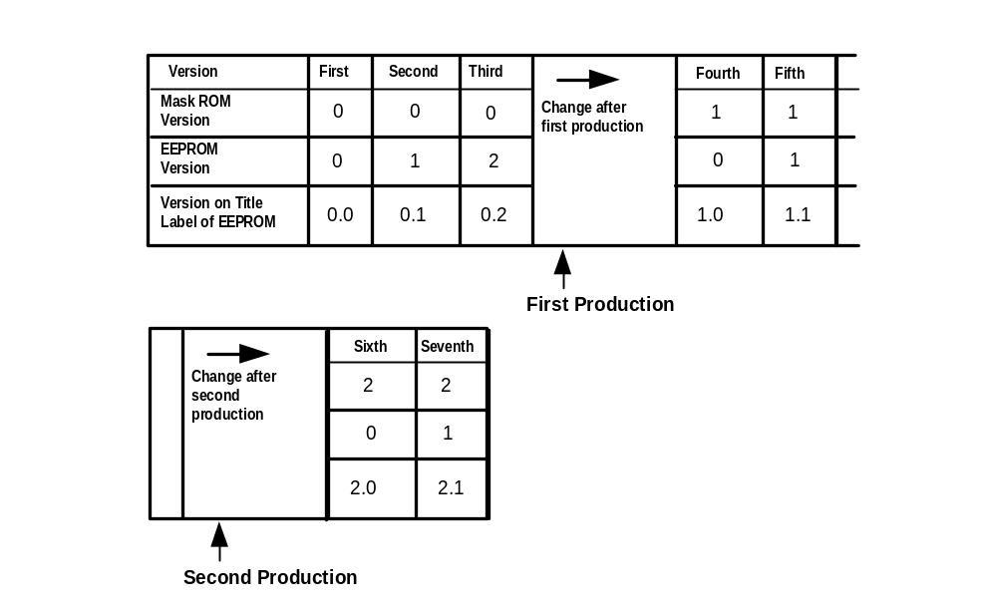

3.13 Game Title
Indicate the Game Title registered in each designated address in the Master ROM, along with the Game Code.
Refer to Section 5. Character Code List for Game Title Registration (page 10) and Section 6. ROM Registration Data Specifications (page 11), for information on codes that can be used with Game Titles.
(Note) Use 20h for spaces within the Game Title. 00h may be used to fill unused portions following the Game Title.

3.14 ROM Registration Data
Indicate content registered in each designated address of the Master ROM.
For detailed information on ROM registration data, refer to Section 6. ROM Registration Data Specifications (page 11),
In the parenthesis in the data column, enter ASCII characters (alphanumeric).

3.15 File Name and CRC
- File Name
Check either CD-R or FTP, and indicate the file name.
Use the following format for file names.

(Note) For more details, refer to Section 4. Saving Data to a Disk (page 9).

A**** **. SRL
ROM Version

Game Code
- CRC
Calculate CRC using the AGB CRC Check Utility software provided by Nintendo of America Inc.
(Note) Download the AGB CRC Check Utility software from our web site, http://www.noa-engineering.com.

3.16 Programming Features
Special Programmiing
For copy protection indicate if special programming has been done.
If special programming for copy protection is in use, include an explanation of its content in the "Remarks".

Section 4. Saving Data to a Disk
1. For media, use a CD-R (or FTP).
2. For the data format, use binary/uncompressed. Ensure Master ROM size equals the Mask ROM size ordered.
3. Write the file name in the following format.

A**** **. SRL
ROM Version(2 digits)

Game Code(4 digits)

[Example] - Game Code = “AMAE”
- ROM Version=”0.2”
File Name =”AAMAE02. SRL”
4. Indicate the following information on the CD-R.
Company name/Game Title/Game Code/File Name/CRC/Date
(Note) To prevent labels from coming off in the CD drive with CD-R, use CD labels, or write directly on the CD-R.
Also, when sending please insert in a CD jewel case.

[Example of a Label for CD]

Company Name: Nintendo of America Inc.
Game Title: Mario Advance
Game Code: AGB – P – AMAE (USA)
File Name: AAMAE00. SRL
CRC: ABCDH
Date: 12/25/2001

Section 5. Character Code List for Game Title Registration
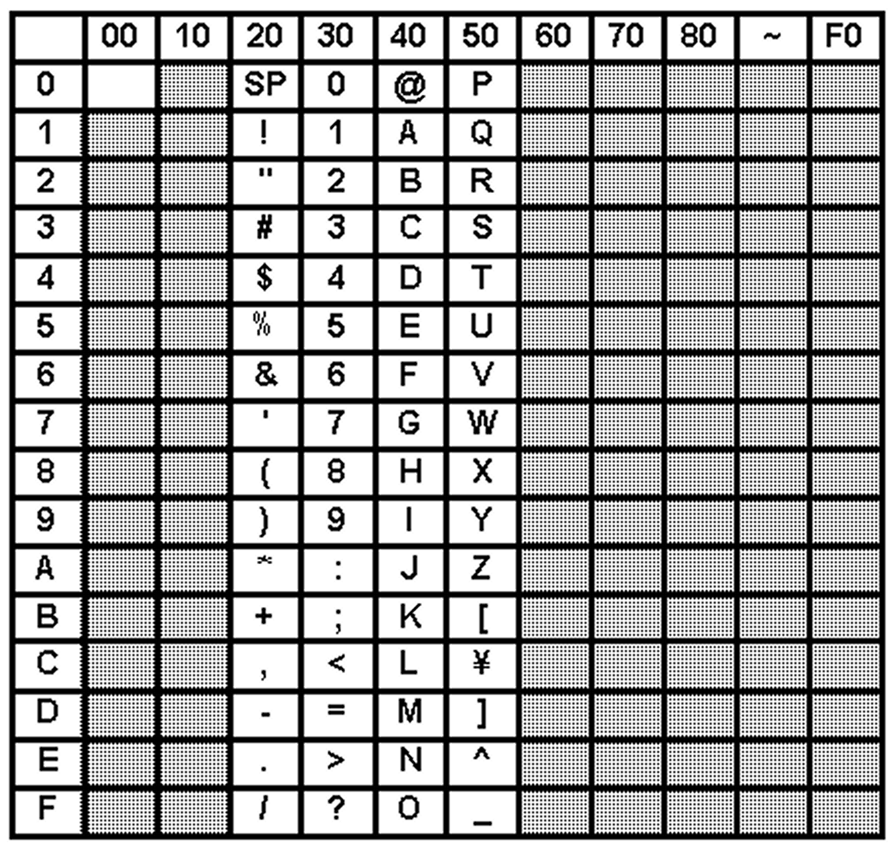

Note 1: Do not use characters in shaded areas for Game Boy Advance titles.
Note 2: Use 20H (SP) for spaces within the Game Title.
Note 3: Use 00H for unused areas after the Game Title.

Example: If ASCII character is "A", ASCII code is "41".

Section 6. ROM Registration Data Specifications
For the Game Boy Advance program, set information for Game Title, Game Pak specifications, etc. in designated addresses in the ROM.
The registration data addresses are 32 bytes located in the CPU memory from 80000A0H-80000BFH.
Record the ROM registration data in the format described below.
[Caution]
The data in the following addresses need to remain fixed, regardless of the Game Title or Game Code.

Address 80000B2H＝96H
Address 80000B5H-80000BBH＝00H
Address 80000BEH-80000BFH＝00H

6.1 Game Title (80000AOH-80000ABH)
Store the Game Title with ASCII Code 20H-5FH and 00H.
Do not use katakana or lower case letters.
Use 20H for blank spaces within the Game Title, and 00H for unused portions after the Game Title.
For information on characters that can be used refer to Section 5. Character Code List for Game Title Registration (page 10).
The Game Title saved here is not the development name. Use a name that clearly identifies the actual product name.
[Example]
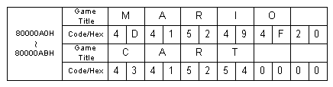

6.2 Game Code (80000ACH-80000AFH)
Register the four digit Game Code, established for the game, in ASCII code (English characters should be capitalized).
[Example]
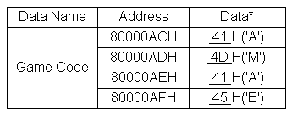
If the Game Code is “AMAE”:

6.3 Maker Code (80000BOH, 80000B1H)
Save this in ASCII code (English characters must be capitalized) using the 2 digit code assigned by Nintendo of America Inc. when contracts were completed.

[Example]
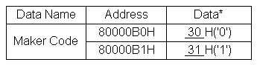
If the Maker Code is “01”:

6.4 Main Unit Code (80000B3H)
Save the code of the main unit to be used with this product’s game program.

Address 80000B3H | Main Unit
00H | Game Boy Advance
(Note) Currently, no data other than 00H is used.

6.5 Device Type (80000B4H)
Save the code for the device type used with the Game Pak.

Address 80000B4H | Device Type
00H | Normal
(Note) Currently, no data other than 00H is used.

6.6 Mask ROM Version Number (80000BCH)
Save the Mask ROM version number for the produced product.
Update if the Mask ROM program has been revised.
[Example]
If submission ROM version is 0.0, 0.1, 0.2… → Data “00H”
“ “ “ 1.0, 1.1, 1.2… → Data “01H”

6.7 Complement Check (80000BDH)
Add 19H to the sum of all the data in Addresses 80000A0H-80000BCH, and save 2’s complement.
(80000A0H)+(80000A1H)+(80000A2H)+…+(80000BCH)+19H+(80000BDH)=00H
Complement

6.8 Reserved Area
The data stored in the Reserved Area is unrelated to the game. Store the fixed values listed below.
Address 80000B2H = 96H
Address 80000B5H ~ 80000BBH = 00H
Address 80000BEH ~ 80000BFH = 00H

Game Title |  |  |  |  |  |  |  |  |  |  |  |  |  |  | ROM Version
Game Code |  | AGB-P- (USA) |  |  |  |  |  |  |  |  |  |  |  |  | Mask ROM |  |  | 0 1 2 3 4 E
Language |  | English Japanese Other ( ) |  |  |  |  |  |  |  |  |  |  |  |  | Submission ROM |  |  | 0 1 2 3 4 5
P  E  R  I  P  H  E  R  A  L  D  E  V  I  C  E  S | Supports AGB Game Link Cable | Multi Game Pak Support *1 |  |  | N |  |  | Y |  | 2 3 4 Player Support |  |  |  |  | ROM Registration Data
 |  |  |  |  |  |  |  |  |  | Same Game  Other Game (Title: ) |  |  |  |  | 80000A0H  to  80000ABH | Game Title
P  E  R  I  P  H  E  R  A  L  D  E  V  I  C  E  S | Supports AGB Game Link Cable | Single Game Pak Support *2 |  |  | N |  |  | Y |  | 2 3 4 Player Support |  |  |  |  | 80000A0H  to  80000ABH | Code/Hex
 |  |  |  |  |  |  |  |  |  | Number of Game Paks Supported |  | 1 2  3 4 |  |  | 80000A0H  to  80000ABH | Game Title
 |  |  |  |  |  |  |  |  |  | Same Game  Other Game (Title: ) |  |  |  |  | 80000A0H  to  80000ABH | Code/Hex
 |  |  |  |  |  |  |  |  |  | Difference in game with number of Game Paks |  | N | Y |  | * For software title registration, use the "Character Code List" on page 10. The code for a space is 20H. The code for unused areas is 00H.
P  E  R  I  P  H  E  R  A  L  D  E  V  I  C  E  S | Supports AGB Game Link Cable | If you answered "Y" to both *1 and *2 above, is there a difference in specifications for Multi Game Pak Mode and Single Game Pak Mode? |  |  |  |  |  |  |  |  |  | N | Y |  | Data Name |  | Address |  |  |  | Data* |  |  | Data Name |  |  |  | Address |  |  | Data*
 |  |  |  |  |  |  |  |  |  |  |  |  |  |  | Game Code |  | 80000ACH |  |  |  | H (' ') |  |  | Device Type |  |  |  | 80000B4H |  |  | H
P  E  R  I  P  H  E  R  A  L  D  E  V  I  C  E  S | Supports Infrared Communication | N | Y | Same Game  Other Game (Title: ) |  |  |  |  |  |  |  |  |  |  |  |  | 80000ADH |  |  |  | H (' ') |  |  | Reserved Area |  |  |  | 80000B5H  to  80000BBH |  |  | 00H
 |  |  |  |  |  |  |  |  |  |  |  |  |  |  |  |  | 80000AEH |  |  |  | H (' ')
P  E  R  I  P  H  E  R  A  L  D  E  V  I  C  E  S | Supports Other Peripheral Devices | N | Y | Device Name (Title: ) |  |  |  |  |  |  |  |  |  |  |  |  | 80000AFH |  |  |  | H (' ') |  |  | Mask ROM Version |  |  |  | 80000BCH |  |  | H
 |  |  |  |  |  |  |  |  |  |  |  |  |  |  | Maker Code |  | 80000B0H |  |  |  | H (' ') |  |  | Complement Check |  |  |  | 80000BDH |  |  | H
Overseas Version  (Or planned version) |  | N | Y | Game Title:  Game Code: AGB-P- ( ) |  |  |  |  |  |  |  |  |  |  |  |  | 80000B1H |  |  |  | H (' ')
 |  |  |  |  |  |  |  |  |  |  |  |  |  |  | Fixed Value* |  | 80000B2H |  |  |  | 96H |  |  | Reserved Area |  |  |  | 80000BEH  to  80000BFH |  |  | 00H
C  O  N  T  A  C  T | Company/Dept. |  |  |  |  |  |  |  |  |  |  |  |  |  | Main Unit Code |  | 80000B3 |  |  |  | H
C  O  N  T  A  C  T | Name |  |  |  |  |  |  |  | E-mail: |  |  |  |  |  | * Insert ASCII characters in parenthesis (' '). Always use 96H for 80000B2H.
C  O  N  T  A  C  T | Address | Line 1:  Line 2:  Tel: Fax: |  |  |  |  |  |  |  |  |  |  |  |  | File Name and CRC
C  O  N  T  A  C  T | Address |  |  |  |  |  |  |  |  |  |  |  |  |  | Disk | CD-R
Submission Date |  | / /  MM/DD/YYYY |  |  |  | Method of Submission |  |  |  | Mail FTP |  |  |  |  | File Name | A .SRL
 |  |  |  |  |  |  |  |  |  |  |  |  |  |  | CRC | H
Launch Date |  | / /  MM/DD/YYYY |  |  |  |  |  |  |  |  |  |  |  |  | Programming Features
 |  |  |  |  |  |  |  |  |  |  |  |  |  |  | Special Programming for Copy Protection |  |  |  | N |  |  | Y (Attach Explanation)
(*1) Multi Game Pak Support: Specifications call for a Game Pak inserted in each AGB connected.
(*2) Single Game Pak Support: Specifications allow for game play with a fewer number of Game Paks than there are AGBs connected.
Memory Configuration |  |  |  |  |  |  |  |  |  |  |  |  |  |  | Remarks
ROM |  | Size: Bits |  |  |  |  |  |  |  |  |  |  |  |  |  |  |  |  |  |  |  |  |  |  |  |  |  |  | Nintendo/Received
Backup Memory Specifications |  | N | Y | Bits |  |  |  | EEPROM
 |  |  |  |  |  |  |  | SRAM |  |  | Backup Battery  Required Not Required
 |  |  |  |  |  |  |  | Program to avoid loss of SRAM: Level:
 |  |  |  |  |  |  |  | Flash Memory |  |  |  |  |  |  |  |  |  |  |  |  |  |  |  |  |  |  |  |  | D.C.N. AGB-06-0020-001A
 |  | N | Y | Backup Library |  |  | Version . .  Normal Fast (Only if SRAM is checked)

Software Destination Declaration/Checklist

Fax to: NOA Lot Check (425)-861-2845

Please fill out completely

Date: ___________

A version of has been sent to Nintendo of America Inc. The software was
Software title
developed by for .
Developer Publisher

This software is to be forwarded to the appropriate person(s) in the department(s) marked below. This software should not be distributed to any other person(s), or used for any other purposes than those expressly marked below.

Purpose of Submission:

Method of submission: CD-ROM/Floppy Disk or FTP to folder
Co. Name

Departments which should have access to this submission:

Departments:
____ Mario Club ____ Nintendo Power Product Acquisition

____ Lot Check NOA Licensing

Individuals:
__________________________________________________________________________________
__________________________________________________________________________________
__________________________________________________________________________________

PROGRAM INFORMATION:

____ Game Boy ____ DMG/CGB-Dual ____ CGB Only ____ AGB ____ N64 ____ NUSG

PROGRAM SIZE (in Mbits):

EEPROM, SRAM, FLASH RAM YES NO SIZE: _____

RUMBLE PAK: YES NO

CONTROLLER PAK: YES NO

# of Notes_______ # of Pages______ Note Name(s): ________________________________________

EXPANSION PAK (RAM): YES NO
Other features (IR communication, password, etc.): __________________________________________
Include the following information/materials with each version:

____ Software Specification Sheet (for Lot Check) or __________ Checksum value (for others)

____ ROM Image File (submit via FTP, or mail on CD-ROM/3.5" floppy disk). All disks will be destroyed after receipt of game into our system.

____ Copy of ESRB Rating Certificate or VHS Tape sent to ESRB (1st submission to Lot Check only).

____ Print out of screen text (first submission to Lot Check only).

____ Copy of Instruction Manual or Game Play Instructions, include description of how and where special features are utilized. (first submission to Lot Check only).

Sender or Contact Person Phone Fax or E-mail

